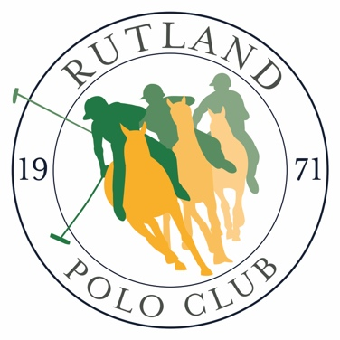

2024 Tournament Dates

MAY
4th- 5th — Spring Cup 0g & Made Cup -4g
18th-19th — Collie Cup 0g
18th-19th — Escalina/ Millera WIP 12g/8g

JUNE
19th-23rd — Assam Cup VL 4g
22nd-23rd — Findlay Cup 0g,
Findlay Plate -6g

JULY
26th — Juniors “Belvoir Cup’ (Jr players only)
27th-28th — Preston Lodge -2g,
Ranksboro WIP 4g

AUGUST
24th-25th — Gilks Trophy 2g,
Sandicliffe 0g, Ruddles Trophy -3g

SEPTEMBER
21st-25st — Wilkinson Sword -2g &
Bronze Horse -4g

