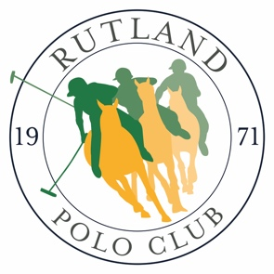
Rutland Polo Club
Corporate Sponsorship & Advertising Packages 2022

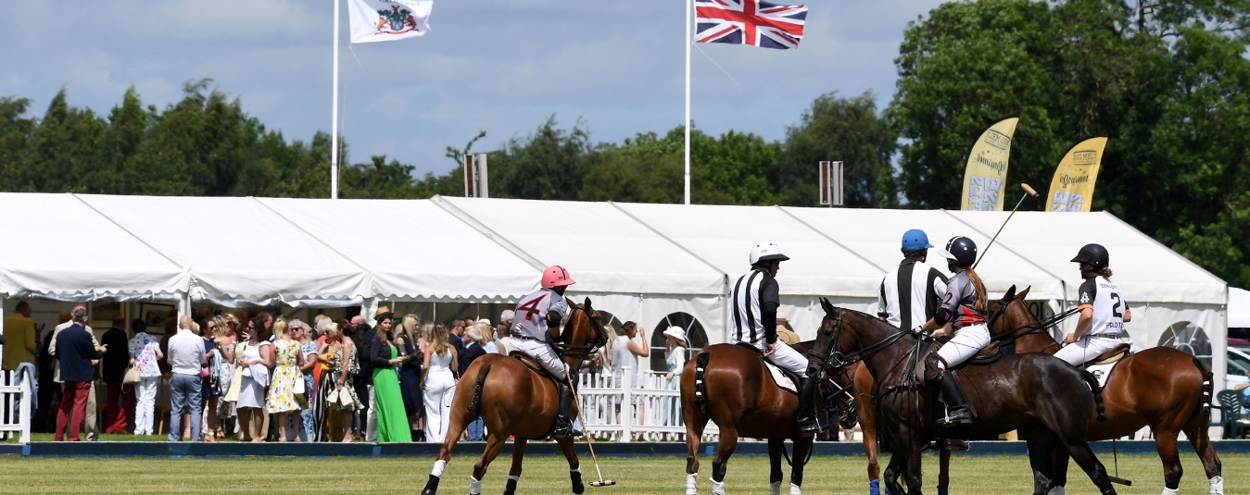
Season Corporate Membership:
- Your logo on our corporate members page on website
- Choice of advertising board on club house or fence banner as you enter ground (member to provide)
- ¼ page advert in main tournament programmes
- Four entry tickets to all tournaments
- Four complimentary souvenir programmes for every tournament
- Pitch side parking for up to one vehicle and space for own gazebo and own display stand at every match*
- 10% off any additional sponsorship packages
£350.00 per season
*If you don’t want the hassle of bringing your own picnic Rutland Polo Club can cater for you and your guests and provide you with a table and chairs for as little as £23 per person.
Member upgrades:
- Promote your business all season with scoreboard sponsorship with large display board: £250
- Promote your business all season with commentary box sponsorship with large display board: £375
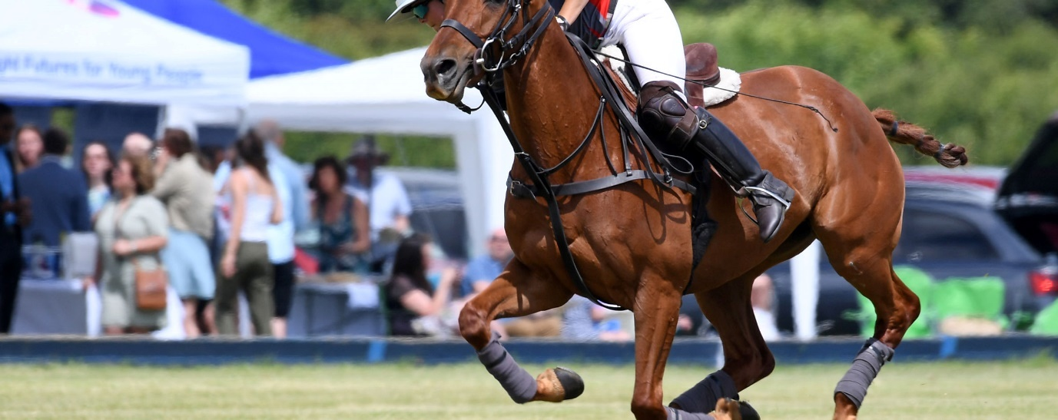
Fixture: 28th-29th May Tournament Weekend comprising
WIP Millera Plate
WIP Escalina
Collie Cup
Match sponsorship:
Have the prestige of sponsoring and watching your own polo game and promote your business all weekend, also included in the package:
- Eight entry tickets for you and your guests on the day of your sponsored match
- Pol Roger Champagne reception in our club house marquee
- A table for eight guests and buffet lunch with x4 bottles of wine in our club house marquee
- Access to the Club bar
- Complimentary tea and coffee served to your guests throughout the day
- Eight complimentary souvenir programmes
- Match side parking for two vehicles plus space for your own gazebo*
- Full page advert in tournament programme
- You or your nominated guest to throw in ball at first Chukka
- Regular commentator mentions for your business during match
- 2ft x 8ft Fence banner upon entry to ground (supplied by you)
- You or a nominated guest to hand out trophy
With only three matches to choose from this highly prestigious package is available for just £550 per match. 10% discount available for subsequent match sponsorship throughout the tournament when booking together.
Additional full hospitality tickets available for £43 per person.

“Having entertained guests and clients at many different sporting events, I can honestly say Rutland Polo Club provides the most friendly, accessible and fun day out we have enjoyed”

29th May Goal Post Sponsorship:
Have your business winning every time when a goal is scored.
By sponsoring a set of goals, your business will be promoted every time a goal is scored, in addition this package comes with the following great benefits:
- Eight entry tickets for you and your guests on the day of your sponsored match
- Champagne reception in our club house marquee
- A table for eight guests and buffet lunch with x4 bottles of wine in our club house marquee
- Access to the Club bar
- Complimentary tea and coffee served to your guests throughout the day
- Eight complimentary souvenir programmes
- Match side parking for two vehicles plus space for your own gazebo
- Full page advert in tournament programme
- 2ft x 8ft Fence banner upon entry to ground (supplied by you)
This fun and great value sponsorship package is priced at only £490 per set of goal posts.
10% discount available for subsequent goal post sponsorship throughout the tournament when booking together.
Additional full hospitality tickets available for £43 per person.
Match Ball Sponsorship
Sponsor a match ball and have your business promoted throughout every chukka, in addition this package comes with the following great benefits:
- Eight entry tickets for you and your guests on the day of your sponsored match
- Champagne reception in our club house marquee
- A table for Eight guests and buffet lunch with x4 bottles of wine in our club house marquee
- Access to the Club bar
- Complimentary tea and coffee served to your guests throughout the day
- Eight complimentary souvenir programmes
- Match side parking for two vehicles plus space for your own gazebo
- Full page advert in tournament programme
- 2ft x 8ft Fence banner upon entry to ground (supplied by you)
- Your match ball signed by the teams and presented to you at the end of the match.
This fun and great value sponsorship package is priced at only £490 per ball.
10% discount available for subsequent goal post sponsorship throughout the tournament when booking together.
Additional full hospitality tickets available for £43 per person.

“Finding something different to entertain clients is really difficult, but Rutland Polo Club have definitely found the answer”

29th May Best Turned Out Pony Sponsorship
It is custom to recognise the best polo pony of a match and as such we have this unique opportunity for you to sponsor and award the best turned out pony.
You will present the pony with a rug, which can bear your business logo for promotion purposes and receive promotional photographs of the occasion.
This stand alone sponsorship offer is just £175, including the cost of embroidered rug for you to present, which will be worn and paraded by the winning pony.
29th May Corporate Hospitality
Entertain your guests in style at Rutland Polo Club:
- Eight entry tickets for you and your guests on the day of your sponsored match
- Champagne reception in our club house marquee
- A table for Eight guests and buffet lunch with x4 bottles of wine in our club house marquee
- Access to the Club bar
- Complimentary tea and coffee served to your guests throughout the day
- Eight complimentary souvenir programmes
- Match side parking for up to two vehicles plus space for your own gazebo
£450 per table of Eight
Additional full hospitality tickets available for £43 per person.

“We booked a table at the polo as a birthday treat for our daughter and have been hooked on the game ever since”

28th to 29th May Park & Picnic
Book a pitch side parking spot for a picnic and entertain your guests from the back of your car. Prices from £25 per parking space on the halfway line to £15 down the pitch.*

*If you don’t want the hassle of bringing your own picnic Rutland Polo Club can cater for you and your guests and provide you with a table and chairs for as little as £23 per person.

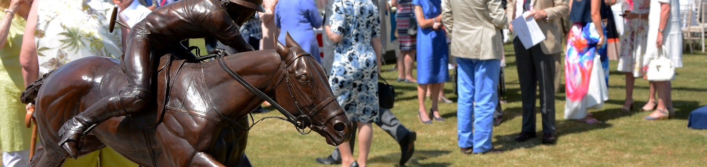
Fixture: 24th to 26th June Rutland Summer Festival of Polo
26th June Assam Cup Final
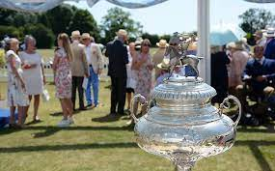
Match sponsorship:
This highly prestigious trophy was brought back from India after the Second World War and has been contested for at Rutland Polo Club for over 50 years.
This is a unique opportunity to sponsor one of the jewels in the crown of Rutland Polo Club and to entertain your guests in style at our Summer Festival of Polo.
Have the prestige of sponsoring and watching your own major polo game and promote your business all weekend, also included in the package:
- Eight entry tickets for you and your guests on the day of your sponsored match
- Pol Roger Champagne reception in our club house marquee
- A table for Eight guests and three course lunch with x5 bottles of wine in our club house marquee
- Access to the Club bar
- Complimentary tea and coffee served to your guests throughout the day
- Eight complimentary souvenir programmes
- Match side parking for up to three vehicles plus space for your own gazebo
- Full page advert in tournament programme
- You or your nominated guest to throw in ball at first Chukka
- Regular commentator mentions for your business during match
- 2ft x 8ft Fence banner upon entry to ground (supplied by you)
- You or a nominated guest to hand out the Assam Cup to the winning team

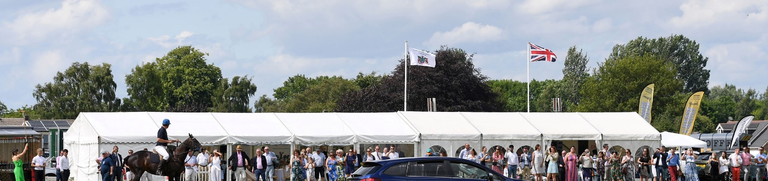
Become the sponsor of this exclusive trophy for £5000.
Additional full hospitality tickets available for £85 per person.
“We find that traditional corporate entertainment invitations are being turned down, except when we invite our clients and their partners to Rutland Polo Club, where we always end up booking more places each year”
26th June Assam Cup Goal Post Sponsorship:
Have your business winning every time when a goal is scored.
By sponsoring a set of goals, your business will be promoted every time a goal is scored, in addition this package comes with the following great benefits:
- Eight entry tickets for you and your guests on the day of your sponsored match
- Champagne reception in our club house marquee
- A table for Eight guests and buffet lunch with x4 bottles of wine in our club house marquee
- Access to the Club bar
- Complimentary tea and coffee served to your guests throughout the day
- Eight complimentary souvenir programmes
- Match side parking for up to two vehicles plus space for your own gazebo
- Full page advert in tournament programme
- 2ft x 8ft Fence banner upon entry to ground (supplied by you)
This fun and great value sponsorship package is priced at only £1500 per set of goal posts/match.
Additional full hospitality tickets available for £85 per person.
26th June Assam Cup Match Ball Sponsorship
Sponsor a match ball and have your business promoted throughout every chukka, in addition this package comes with the following great benefits:
- Eight entry tickets for you and your guests on the day of your sponsored match
- Champagne reception in our club house marquee
- A table for Eight guests and three course lunch with x5 bottles of wine in our club house marquee
- Access to the Club bar
- Complimentary tea and coffee served to your guests throughout the day
- Eight complimentary souvenir programmes
- Match side parking for up to two vehicles plus space for your own gazebo
- Full page advert in tournament programme
- 2ft x 8ft Fence banner upon entry to ground (supplied by you)
- Your match ball signed by the teams and presented to you at the end of the match.
This fun and great value sponsorship package is priced at only £1500 per ball/match.
10% discount available for subsequent goal post sponsorship throughout the tournament when booking together.
Additional full hospitality tickets available for £85 per person.

By sponsoring an event at Rutland Polo Club, you are contributing to keeping the club alive and supporting the work we do to engage with the local community

Assam Cup Best Turned Out Pony Sponsorship
It is custom to recognise the best polo pony of a match and as such we have this unique opportunity for you to sponsor and award the best turned out pony.
You will present the pony with a rug, which can bear your business logo for promotion purposes and receive promotional photographs of the occasion.
This stand alone sponsorship offer is just £275, including the cost of embroidered rug for you to present, which will be worn and paraded by the winning pony.

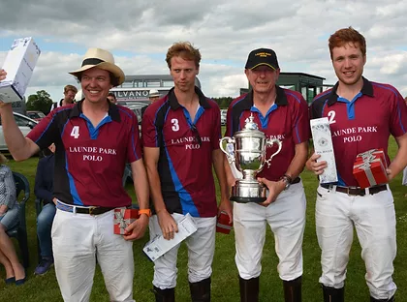
26th June Findlay Cup Final
Match sponsorship:
This is fabulous trophy is also played for during our Summer Festival of Polo and provides a unique opportunity to sponsor one of the key matches during this busy weekend at Rutland Polo Club, whilst you entertain your guests in style.
Have the prestige of sponsoring and watching your own major polo game and promote your business all weekend, also included in the package:
- Eight entry tickets for you and your guests on the day of your sponsored match
- Pol Roger Champagne reception in our club house marquee
- A table for Eight guests and three course lunch with x5 bottles of wine in our club house marquee
- Access to the Club bar
- Complimentary tea and coffee served to your guests throughout the day
- Eight complimentary souvenir programmes
- Match side parking for up to three vehicles plus space for your own gazebo*
- Full page advert in tournament programme
- You or your nominated guest to throw in ball at first Chukka
- Regular commentator mentions for your business during match
- 2ft x 8ft Fence banner upon entry to ground (supplied by you)
- You or a nominated guest to hand out the Findlay Cup to the winning team
Become the sponsor of this exclusive trophy for £2500.

26th June Findlay Cup Goal Post Sponsorship:
Have your business winning every time when a goal is scored.
By sponsoring a set of goals, your business will be promoted every time a goal is scored, in addition this package comes with the following great benefits:
- Eight entry tickets for you and your guests on the day of your sponsored match
- Champagne reception in our club house marquee
- A table for Eight guests and three course lunch with x5 bottles of wine in our club house marquee
- Access to the Club bar
- Complimentary tea and coffee served to your guests throughout the day
- Eight complimentary souvenir programmes
- Match side parking for up to two vehicles plus space for your own gazebo
- Full page advert in tournament programme
- 2ft x 8ft Fence banner upon entry to ground (supplied by you)
This fun and great value sponsorship package is priced at only £975 per set of goal posts.
26th June Findlay Cup Match Ball Sponsorship
Sponsor a match ball and have your business promoted throughout every chukka, in addition this package comes with the following great benefits:
- Eight entry tickets for you and your guests on the day of your sponsored match
- Champagne reception in our club house marquee
- A table for Eight guests and three course lunch with x5 bottles of wine in our club house marquee
- Access to the Club bar
- Complimentary tea and coffee served to your guests throughout the day
- Eight complimentary souvenir programmes
- Match side parking for up to two vehicles plus space for your own gazebo
- Full page advert in tournament programme
- 2ft x 8ft Fence banner upon entry to ground (supplied by you)
- Your match ball signed by the teams and presented to you at the end of the match.
This fun and great value sponsorship package is priced at only £975 per ball/match.
10% discount available for subsequent match ball or goal post sponsorship throughout the tournament when booking together.
Additional full hospitality tickets available for £85 per person.

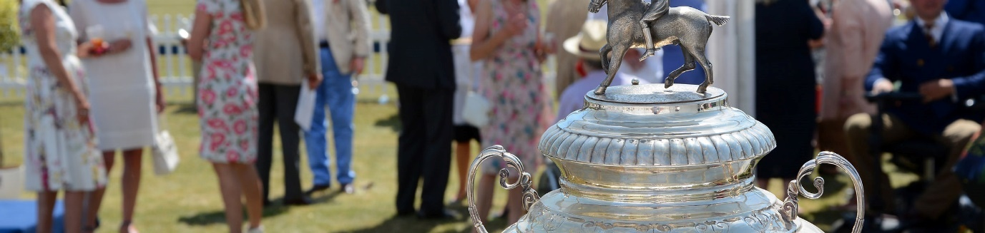
Findlay Cup Best Turned Out Pony Sponsorship
It is custom to recognise the best polo pony of a match and as such we have this unique opportunity for you to sponsor and award the best turned out pony.
You will present the pony with a rug, which can bear your business logo for promotion purposes and receive promotional photographs of the occasion.
This stand alone sponsorship offer is just £225, including the cost of embroidered rug for you to present, which will be worn and paraded by the winning pony.

26th June Corporate Hospitality
Entertain your guests in style at Rutland Polo Club Summer Festival of Polo:
- Eight entry tickets for you and your guests on the day of your sponsored match
- Champagne reception in our club house marquee
- A table for Eight guests and three course lunch with x5 bottles of wine in our club house marquee
- Access to the Club bar
- Complimentary tea and coffee served to your guests throughout the day
- Eight complimentary souvenir programmes
- Match side parking for up to two vehicles plus space for your own gazebo
£850 per table

Park & Picnic at Rutland Summer Festival of Polo
Book a pitch side parking spot for a picnic and entertain your guests from the back of your car. Prices from £50 per parking space on the halfway line to £35 down the pitch.*

*If you don’t want the hassle of bringing your own picnic Rutland Polo Club can cater for you and your guests and provide you with a table and chairs for as little as £23 per person.

Fixture: 16th to 17th July Preston Lodge Bowl
Match sponsorship:
Have the prestige of sponsoring and watching your own polo game and promote your business all weekend, also included in the package:
- Eight entry tickets for you and your guests on the day of your sponsored match
- Pol Roger Champagne reception in our club house marquee
- A table for Eight guests and buffet lunch with x4 bottles of wine in our club house marquee
- Access to the Club bar
- Complimentary tea and coffee served to your guests throughout the day
- Eight complimentary souvenir programmes
- Match side parking for two vehicles plus space for your own gazebo*
- Full page advert in tournament programme
- You or your nominated guest to throw in ball at first Chukka
- Regular commentator mentions for your business during match
- 2ft x 8ft Fence banner upon entry to ground (supplied by you)
- You or a nominated guest to hand out trophy
This highly prestigious package is available for just £550.
Additional full hospitality tickets available for £43 per person.
17th July Preston Bowl Goal Post Sponsorship:
Have your business winning every time when a goal is scored.
By sponsoring a set of goals, your business will be promoted every time a goal is scored, in addition this package comes with the following great benefits:
- Eight entry tickets for you and your guests on the day of your sponsored match
- Champagne reception in our club house marquee
- A table for Eight guests and buffet lunch with x4 bottles of wine in our club house marquee
- Access to the Club bar
- Complimentary tea and coffee served to your guests throughout the day
- Eight complimentary souvenir programmes
- Match side parking for up to two vehicles plus space for your own gazebo
- Full page advert in tournament programme
- 2ft x 8ft Fence banner upon entry to ground (supplied by you)
This fun and great value sponsorship package is priced at only £490 per set of goal posts.
10% discount available for subsequent goal post sponsorship throughout the tournament when booking together.
Additional full hospitality tickets available for £43 per person.

Preston Bowl Best Turned Out Pony Sponsorship
It is custom to recognise the best polo pony of a match and as such we have this unique opportunity for you to sponsor and award the best turned out pony.
You will present the pony with a rug, which can bear your business logo for promotion purposes and receive promotional photographs of the occasion.
This stand alone sponsorship offer is just £175, including the cost of embroidered rug for you to present, which will be worn and paraded by the winning pony.

17th July Corporate Hospitality
Entertain your guests in style at Rutland Polo Club:
- Eight entry tickets for you and your guests on the day of your sponsored match
- Champagne reception in our club house marquee
- A table for Eight guests and buffet lunch with x4 bottles of wine in our club house marquee
- Access to the Club bar
- Complimentary tea and coffee served to your guests throughout the day
- Eight complimentary souvenir programmes
- Match side parking for up to two vehicles plus space for your own gazebo
£450 per table of Eight
Additional full hospitality tickets available for £43 per person.
17th July Park & Picnic
Book a pitch side parking spot for a picnic and entertain your guests from the back of your car. Prices from £25 per parking space on the halfway line to £15 down the pitch.*

*If you don’t want the hassle of bringing your own picnic Rutland Polo Club can cater for you and your guests and provide you with a table and chairs for as little as £23 per person.
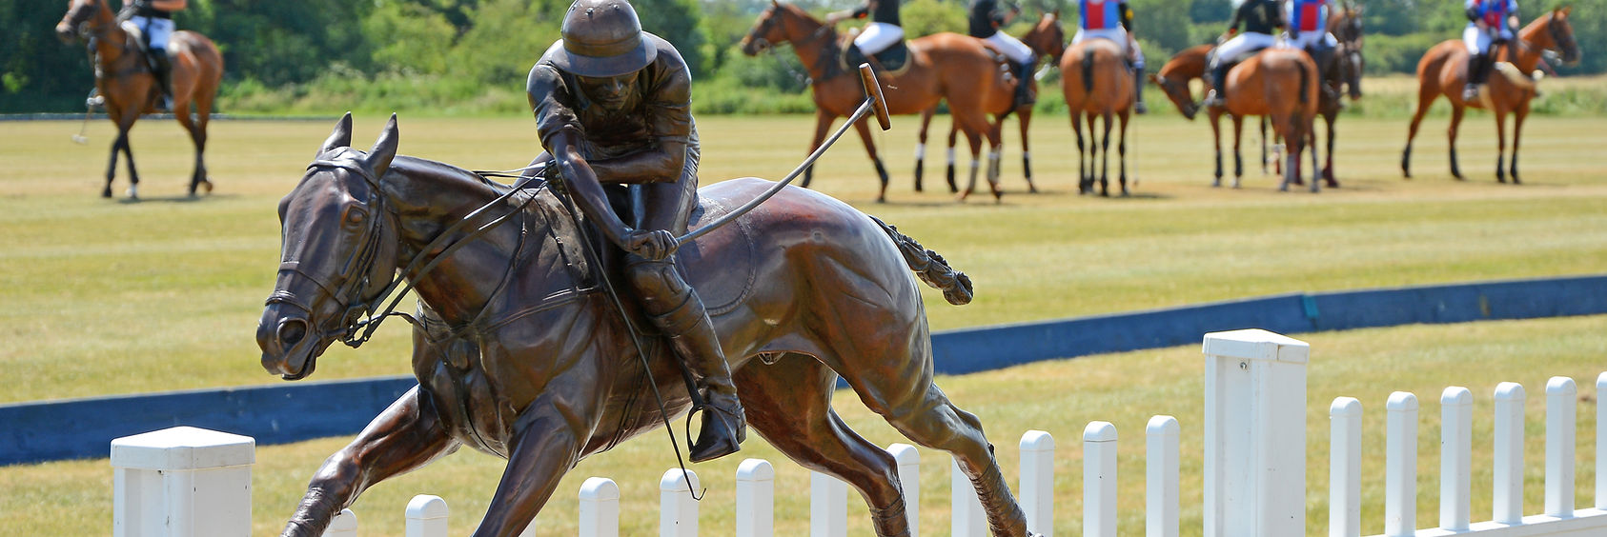
Fixture: 6th to 7th August
WIP Ladies Cordoba Cup
WIP Ladies Ranksboro Cup
Gilkes Trophy
7th August Match sponsorship:
Have the prestige of sponsoring and watching your own polo game and promote your business all weekend, also included in the package:
- Eight entry tickets for you and your guests on the day of your sponsored match
- Pol Roger Champagne reception in our club house marquee
- A table for Eight guests and buffet lunch with x4 bottles of wine in our club house marquee
- Access to the Club bar
- Complimentary tea and coffee served to your guests throughout the day
- Eight complimentary souvenir programmes
- Match side parking for two vehicles plus space for your own gazebo*
- Full page advert in tournament programme
- You or your nominated guest to throw in ball at first Chukka
- Regular commentator mentions for your business during match
- 2ft x 8ft Fence banner upon entry to ground (supplied by you)
- You or a nominated guest to hand out trophy
With only three matches to choose from this highly prestigious package is available for just £870 per match. 10% discount available for subsequent match sponsorship throughout the tournament when booking together.
Additional full hospitality tickets available for £43 per person.
7th August Goal Post Sponsorship:
Have your business winning every time when a goal is scored.
By sponsoring a set of goals, your business will be promoted every time a goal is scored, in addition this package comes with the following great benefits:
- Eight entry tickets for you and your guests on the day of your sponsored match
- Champagne reception in our club house marquee
- A table for Eight guests and buffet lunch with x4 bottles of wine in our club house marquee
- Access to the Club bar
- Complimentary tea and coffee served to your guests throughout the day
- Eight complimentary souvenir programmes
- Match side parking for two vehicles plus space for your own gazebo
- Full page advert in tournament programme
- 2ft x 8ft Fence banner upon entry to ground (supplied by you)
This fun and great value sponsorship package is priced at only £490 per set of goal posts.
10% discount available for subsequent goal post sponsorship throughout the tournament when booking together.
Additional full hospitality tickets available for £43 per person.
7th August Match Ball Sponsorship
Sponsor a match ball and have your business promoted throughout every chukka, in addition this package comes with the following great benefits:
- Eight entry tickets for you and your guests on the day of your sponsored match
- Champagne reception in our club house marquee
- A table for Eight guests and buffet lunch with x4 bottles of wine in our club house marquee
- Access to the Club bar
- Complimentary tea and coffee served to your guests throughout the day
- Eight complimentary souvenir programmes
- Match side parking for two vehicles plus space for your own gazebo
- Full page advert in tournament programme
- 2ft x 8ft Fence banner upon entry to ground (supplied by you)
- Your match ball signed by the teams and presented to you at the end of the match.
This fun and great value sponsorship package is priced at only £490 per ball.
10% discount available for subsequent goal post sponsorship throughout the tournament when booking together.
Additional full hospitality tickets available for £43 per person.
7th August Best Turned Out Pony Sponsorship
It is custom to recognise the best polo pony of a match and as such we have this unique opportunity for you to sponsor and award the best turned out pony.
You will present the pony with a rug, which can bear your business logo for promotion purposes and receive promotional photographs of the occasion.
This stand alone sponsorship offer is just £275, including the cost of embroidered rug for you to present, which will be worn and paraded by the winning pony.

7th August Corporate Hospitality
Entertain your guests in style at Rutland Polo Club:
- Eight entry tickets for you and your guests on the day of your sponsored match
- Champagne reception in our club house marquee
- A table for Eight guests and buffet lunch with x4 bottles of wine in our club house marquee
- Access to the Club bar
- Complimentary tea and coffee served to your guests throughout the day
- Eight complimentary souvenir programmes
- Match side parking for up to two vehicles plus space for your own gazebo
£450 per table of Eight
Additional full hospitality tickets available for £43 per person.
7th August Park & Picnic
Book a pitch side parking spot for a picnic and entertain your guests from the back of your car. Prices from £25 per parking space on the halfway line to £15 down the pitch.*

*If you don’t want the hassle of bringing your own picnic Rutland Polo Club can cater for you and your guests and provide you with a table and chairs for as little as £23 per person.

Fixture: 27th to 28th August
Ruddles Cup
Sandicliffe Trophy
Match sponsorship:
Have the prestige of sponsoring and watching your own polo game and promote your business all weekend, also included in the package:
- Eight entry tickets for you and your guests on the day of your sponsored match
- Pol Roger Champagne reception in our club house marquee
- A table for Eight guests and buffet lunch with x4 bottles of wine in our club house marquee
- Access to the Club bar
- Complimentary tea and coffee served to your guests throughout the day
- Eight complimentary souvenir programmes
- Match side parking for two vehicles plus space for your own gazebo*
- Full page advert in tournament programme
- You or your nominated guest to throw in ball at first Chukka
- Regular commentator mentions for your business during match
- 2ft x 8ft Fence banner upon entry to ground (supplied by you)
- You or a nominated guest to hand out trophy
With only two matches to choose from this highly prestigious package is available for just £870 per match. 10% discount available for subsequent match sponsorship throughout the tournament when booking together.
Additional full hospitality tickets available for £43 per person.

Working with schools, community groups and pony clubs, Rutland Polo Club is committed to making the sport of polo accessible and fun for all in a friendly and welcoming environment. To do this we need as much support as possible.

28th August Goal Post Sponsorship:
Have your business winning every time when a goal is scored.
By sponsoring a set of goals, your business will be promoted every time a goal is scored, in addition this package comes with the following great benefits:
- Eight entry tickets for you and your guests on the day of your sponsored match
- Champagne reception in our club house marquee
- A table for Eight guests and buffet lunch with x4 bottles of wine in our club house marquee
- Access to the Club bar
- Complimentary tea and coffee served to your guests throughout the day
- Eight complimentary souvenir programmes
- Match side parking for two vehicles plus space for your own gazebo
- Full page advert in tournament programme
- 2ft x 8ft Fence banner upon entry to ground (supplied by you)
This fun and great value sponsorship package is priced at only £490 per set of goal posts.
10% discount available for subsequent goal post sponsorship throughout the tournament when booking together.
Additional full hospitality tickets available for £43 per person.
28th August Match Ball Sponsorship
Sponsor a match ball and have your business promoted throughout every chukka, in addition this package comes with the following great benefits:
- Eight entry tickets for you and your guests on the day of your sponsored match
- Champagne reception in our club house marquee
- A table for Eight guests and buffet lunch with x4 bottles of wine in our club house marquee
- Access to the Club bar
- Complimentary tea and coffee served to your guests throughout the day
- Eight complimentary souvenir programmes
- Match side parking for two vehicles plus space for your own gazebo
- Full page advert in tournament programme
- 2ft x 8ft Fence banner upon entry to ground (supplied by you)
- Your match ball signed by the teams and presented to you at the end of the match.
This fun and great value sponsorship package is priced at only £490 per ball.
10% discount available for subsequent goal post sponsorship throughout the tournament when booking together.
Additional full hospitality tickets available for £43 per person.

28th August Best Turned Out Pony Sponsorship
It is custom to recognise the best polo pony of a match and as such we have this unique opportunity for you to sponsor and award the best turned out pony.
You will present the pony with a rug, which can bear your business logo for promotion purposes and receive promotional photographs of the occasion.
This stand alone sponsorship offer is just £275, including the cost of embroidered rug for you to present, which will be worn and paraded by the winning pony.

28th August Corporate Hospitality
Entertain your guests in style at Rutland Polo Club:
- Eight entry tickets for you and your guests on the day of your sponsored match
- Champagne reception in our club house marquee
- A table for Eight guests and buffet lunch with x4 bottles of wine in our club house marquee
- Access to the Club bar
- Complimentary tea and coffee served to your guests throughout the day
- Eight complimentary souvenir programmes
- Match side parking for up to two vehicles plus space for your own gazebo
£450 per table of Eight
Additional full hospitality tickets available for £43 per person.
Park & Picnic
Book a pitch side parking spot for a picnic and entertain your guests from the back of your car. Prices from £25 per parking space on the halfway line to £15 down the pitch.*

*If you don’t want the hassle of bringing your own picnic Rutland Polo Club can cater for you and your guests and provide you with a table and chairs for as little as £23 per person.
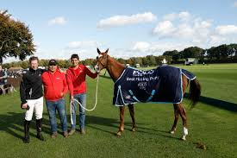
Fixture: 17th to 18th September
Wilkinson Sword Trophy
Bronze Horse Trophy
18th September Final Match sponsorship:
Have the prestige of sponsoring and watching your own polo game and promote your business all weekend, also included in the package:
- Eight entry tickets for you and your guests on the day of your sponsored match
- Pol Roger Champagne reception in our club house marquee
- A table for Eight guests and buffet lunch with x4 bottles of wine in our club house marquee
- Access to the Club bar
- Complimentary tea and coffee served to your guests throughout the day
- Eight complimentary souvenir programmes
- Match side parking for two vehicles plus space for your own gazebo*
- Full page advert in tournament programme
- You or your nominated guest to throw in ball at first Chukka
- Regular commentator mentions for your business during match
- 2ft x 8ft Fence banner upon entry to ground (supplied by you)
- You or a nominated guest to hand out trophy
With only two matches to choose from this highly prestigious package is available for just £630 per match. 10% discount available for subsequent match sponsorship throughout the tournament when booking together.
Additional full hospitality tickets available for £43 per person.
18th September Goal Post Sponsorship:
Have your business winning every time when a goal is scored.
By sponsoring a set of goals, your business will be promoted every time a goal is scored, in addition this package comes with the following great benefits:
- Eight entry tickets for you and your guests on the day of your sponsored match
- Champagne reception in our club house marquee
- A table for Eight guests and buffet lunch with x4 bottles of wine in our club house marquee
- Access to the Club bar
- Complimentary tea and coffee served to your guests throughout the day
- Eight complimentary souvenir programmes
- Match side parking for two vehicles plus space for your own gazebo
- Full page advert in tournament programme
- 2ft x 8ft Fence banner upon entry to ground (supplied by you)
This fun and great value sponsorship package is priced at only £490 per set of goal posts.
20% discount available for subsequent goal post sponsorship throughout the tournament when booking together.
Additional full hospitality tickets available for £43 per person.
18th September Match Ball Sponsorship
Sponsor a match ball and have your business promoted throughout every chukka, in addition this package comes with the following great benefits:
- Eight entry tickets for you and your guests on the day of your sponsored match
- Champagne reception in our club house marquee
- A table for Eight guests and buffet lunch with x4 bottles of wine in our club house marquee
- Access to the Club bar
- Complimentary tea and coffee served to your guests throughout the day
- Eight complimentary souvenir programmes
- Match side parking for two vehicles plus space for your own gazebo
- Full page advert in tournament programme
- 2ft x 8ft Fence banner upon entry to ground (supplied by you)
- Your match ball signed by the teams and presented to you at the end of the match.
This fun and great value sponsorship package is priced at only £490 per ball.
20% discount available for subsequent goal post sponsorship throughout the tournament when booking together.
Additional full hospitality tickets available for £43 per person.

18th September Best Turned Out Pony Sponsorship
It is custom to recognise the best polo pony of a match and as such we have this unique opportunity for you to sponsor and award the best turned out pony.
You will present the pony with a rug, which can bear your business logo for promotion purposes and receive promotional photographs of the occasion.
This stand alone sponsorship offer is just £275, including the cost of embroidered rug for you to present, which will be worn and paraded by the winning pony.

18th September Corporate Hospitality
Entertain your guests in style at Rutland Polo Club:
- Eight entry tickets for you and your guests on the day of your sponsored match
- Champagne reception in our club house marquee
- A table for Eight guests and buffet lunch with x4 bottles of wine in our club house marquee
- Access to the Club bar
- Complimentary tea and coffee served to your guests throughout the day
- Eight complimentary souvenir programmes
- Match side parking for up to two vehicles plus space for your own gazebo
£450 per table of Eight
Additional full hospitality tickets available for £43 per person.
18th September Park & Picnic
Book a pitch side parking spot for a picnic and entertain your guests from the back of your car. Prices from £25 per parking space on the halfway line to £15 down the pitch.*
*If you don’t want the hassle of bringing your own picnic Rutland Polo Club can cater for you and your guests and provide you with a table and chairs for as little as £23 per person.

“We’re delighted to have found such a warm, flexible and accommodating club to welcome us and our guests for such a wonderful day out”

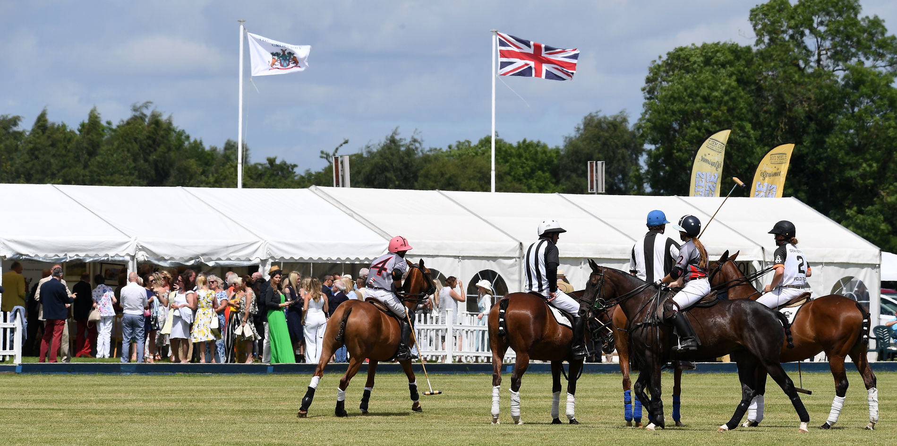

We look forward to you joining us with your guests this season.

